**SQL Tasks: -**

**A) Marketing Analysis:**

1. **Loyal User Reward:** The marketing team wants to reward the most loyal users, i.e., those who have been using the platform for the longest time.  
   Your Task: Identify the five oldest users on Instagram from the provided database.

select * from users order by created_at asc limit 5;

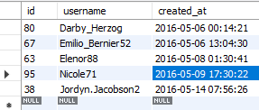

1. **Inactive User Engagement:** The team wants to encourage inactive users to start posting by sending them promotional emails.  
   Your Task: Identify users who have never posted a single photo on Instagram.

select users.id, users.username from users

left join photos on users.id= photos.user_id

where photos.user_id is null;

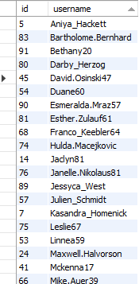 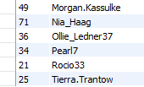

1. **Contest Winner Declaration:** The team has organized a contest where the user with the most likes on a single photo win.  
   Your Task: Determine the winner of the contest and provide their details to the team.

select u.id, u.username,p.id as photo_id,p.image_url,

count(l.user_id) as Total_like_count

from photos as p

inner join likes as l on p.id=l.photo_id

inner join users as u on u.id= p.user_id

group by u.id, u. username, p.id, p.image_url

order by Total_like_count desc

limit 1;



1. **Hashtag Research:** A partner brand wants to know the most popular hashtags to use in their posts to reach the most people.  
   Your Task: Identify and suggest the top five most commonly used hashtags on the platform.

select tags.tag_name, count(*) as most_used_hashtags

from photo_tags

inner join tags

on photo_tags.tag_id=tags.id

group by tag_id

order by most_used_hashtags desc

limit 5;

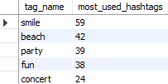

1. **Ad Campaign Launch:** The team wants to know the best day of the week to launch ads.  
   Your Task: Determine the day of the week when most users register on Instagram. Provide insights on when to schedule an ad campaign.

select dayname(created_at) as Registration_Day,

count(username) as Most_People_Registered

from users

group by Registration_Day

order by Most_People_Registered desc

limit 1;



**B) Investor Metrics:**

1. **User Engagement:** Investors want to know if users are still active and posting on Instagram or if they are making fewer posts.  
   Your Task: Calculate the average number of posts per user on Instagram. Also, provide the total number of photos on Instagram divided by the total number of users.

**Approach:** - 1

-- Total number of Active Users

select count(distinct users.id) as Active_User

from users

inner join photos on users.id= photos.user_id;

-- Total number of photos

select count(*) as Total_Photos from photos;

-- Calculating the Average Number of Posts per Active User

select

(select count(*) as Total_Photos from photos)/

(select count(distinct users.id) as Active_User)

from users

inner join photos on users.id= photos.user_id;

Result: - 1.  2. 

3. 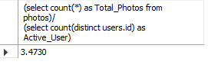

**Approach:** - 2

select

count(distinct users.id) as Active_User,

count(*) as Total_Photo_Posted,

(count(*)/nullif(count(distinct users.id),0)) as

Average_Posts_Per_Active_User

from users

inner join photos on users.id= photos.user_id;

Result: - 

**Both the approaches give the same result but in a different style all together or second approach is merged version of the first query.**

1. **Bots & Fake Accounts:** Investors want to know if the platform is crowded with fake and dummy accounts.  
   Your Task: Identify users (potential bots) who have liked every single photo on the site, as this is not typically possible for a normal user.

-- Step 1: Get the total number of photos

WITH TotalPhotos AS (

SELECT COUNT(*) AS total_photos

FROM photos),

-- Step 2: Count likes for each user

UserLikes AS (

SELECT

likes.user_id,

COUNT(likes.photo_id) AS liked_photos

FROM

likes

GROUP BY

likes.user_id

)

-- Step 3: Identify users who have liked every single photo

SELECT

u.id AS user_id,

u.username

FROM

users AS u

INNER JOIN

UserLikes AS ul ON u.id = ul.user_id

CROSS JOIN

TotalPhotos AS tp

WHERE

ul.liked_photos = tp.total_photos; -- Users who liked all photos

